Christine Brydges
Development Coordinator
Youth Enrichment Services
412 Massachusetts Ave
Boston, MA 02118
(617) 267-5877 x 17
cbrydges@yeskids.org

Freshman Washawn Castro receives Abel Harris Scholarship from
Youth Enrichment Services

FOR IMMEDIATE RELEASE -- Youth Enrichment Services (YES) recently awarded its 2014 Abel Harris Scholarship Fund award to Dorchester native, Washawn Castro. Washawn, now a freshman at UMASS Amherst, was a Junior Volunteer at YES for four years. As a Junior Volunteer, Washawn took part in leadership workshops and taught urban youth ages 7 to 13 how to ski each winter. Throughout his four years at YES, Washawn gained leadership and people skills that proved invaluable for his future.
The Abel Harris scholarship, now in its 26th year, is a need-based award that is given annually to a current or former YES youth enrolled in college who embodies YES’s core values of youth leadership, the positive power of mentoring, and a love of the outdoors. The scholarship funds are raised by Abel's former employer, David Giammatteo, and friends to honor his memory.
Washawn is grateful for the scholarship, which will help him complete his studies at UMass Amherst. After college, he would like to become a criminal justice lawyer to continue his path of leadership and service.

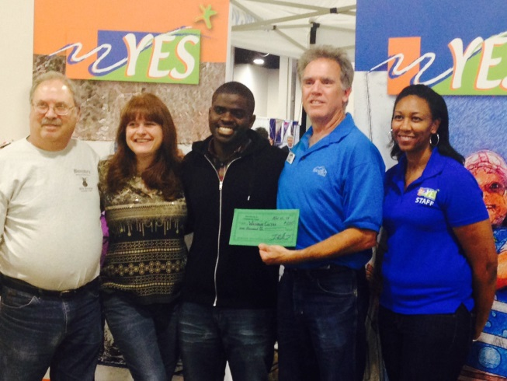
David Giammatteo presents the 2014 Abel
Harris Scholarship to Washawn Castro of Dorchester.

About Youth Enrichment Services - YES has been serving the youth of Boston since 1968 by providing outdoor, sports-based, and leadership programs. YES serves over 1,600 youth annually through its three signature programs: Operation SnowSports, Outdoor Adventure, and the YES Academy. Additional information about Youth Enrichment Services can be found at www.yeskids.org,
Facebook: www.facebook.com/yeskids, Twitter: @yeskidsboston.

### Please contact Christine Brydges, Development Coordinator at (617) 267-5877 X 17 or cbrydges@yeskids.org

