Tues, May 23- YES awards $5,000 to local non-profits
This spring, YES Academy youth were granted $5,000 from The Highland Street Foundation to award to three local non-profits. After conducting site visits at a handful of local non-profits , the YES Academy youth voted on which three non-profits should receive the grant money. The three non-profits selected by YES Academy were the Sunny Meadow Sanctuary, The Children’s Trust, and The Environmental League of Massachusetts.
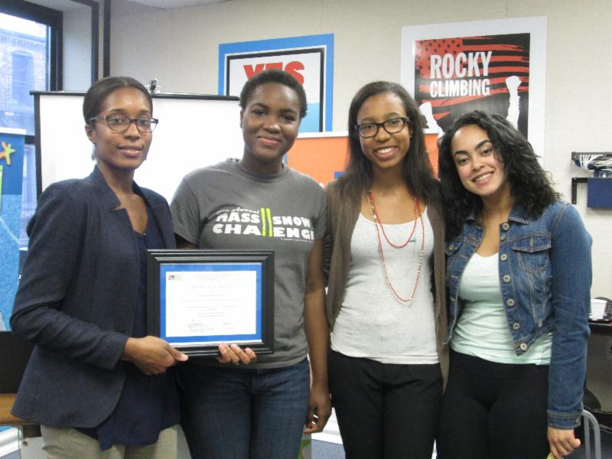
YES Junior Volunteers award a grant to local non-profit The Children’s Trust.
On Tuesday, May 23, YES Academy youth held a reception for the grantees, during whichthey awarded their checks to them and thanked them for the significant work they do in Massachusetts. Congratulations to all of the grant recipients on behalf of YES! To see the other photos from the Youth Philanthropy Ceremony,
For more information about the sites chosen to receive the grant please visit their websites:
- Sunny Meadow Sanctuary (www.sunnymeadowsanctuary.org)
- The Children’s Trust (www.thechildrenstrust.org)
- The Environmental League of Massachusetts (www.thenvironmentalleague.org)

